**IT.3503 - Architecture Virtualisée**

TP 2: An Introduction to Container Management

and Orchestration

GUO Xiaofan

YIN Chenghao

# CONTENT

CONTENT 2

1. Environment Setup 3

1. Install k3s 3

2. Deploy an Application 5

1. Creating a Pod 5

2. Using Manifest files 7

3. Using Controllers 8

3. Expose an Application 11

# Environment Setup

## Install k3s

1. **How many nodes your cluster contains ?**

The cluster contains 1 node, named “gxf”, which is in Ready status and serves as the control plane/master node.



1. **Which container runtime is used ?**

The container runtime used is containerd://1.7.22-k3s1

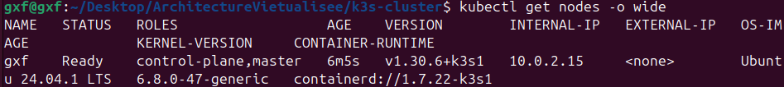

1. **What are the Kubernetes namespace resources defined in your cluster ?**

The Kubernetes namespace resources defined in the cluster are:

**

1. **What are the pods running on your cluster ?**

The cluster is running the following pods in the kube-system namespace: **coredns-7b98449c4-q477m, helm-install-traefik-crd-5zr8g, helm-install-traefik-phzhn, local-path-provisioner-595dffc56f-wb648, metrics-server-ccdc87586-ntnmr, svclb-traefik-0af462d7-j7xvn,** and **traefik-d7c9c5778-zzq99**

1. **What are the lists of replica sets and deployments that you have on you cluster ?**

The cluster has the following replica sets: **coredns-7b98449c4, local-path-provisioner-595dffc56f, metrics-server-ccdc87586,** and **traefik-d7c9c5778**

The cluster has the following deployments: **coredns, local-path-provisioner, metrics-server,** and **traefik**

# Deploy an Application

## 

## Creating a Pod

1. **In which Kubernetes namespace your httpd pod is deployed ?**

The httpd pod is deployed in the default namespace.



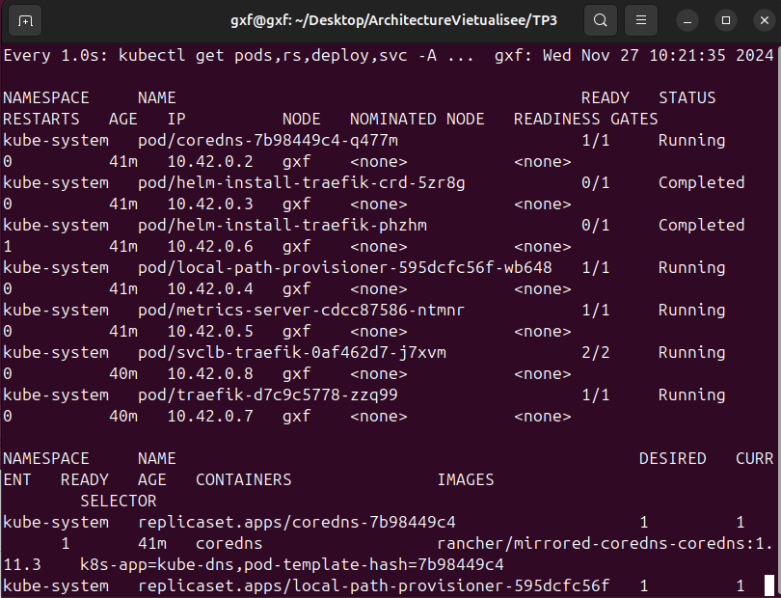

## Using Manifest files

1. **What happens when you delete a namespace ?**

When delete a namespace, all resources within it, including Pods, ReplicaSets, and Deployments, are removed from the cluster.

## Using Controllers

1. **What is the role of the ReplicaSet controller ?**

The ReplicaSet controller ensures that the specified number of pod replicas are running at all times. It continuously monitors the state of the Pods it manages and automatically creates new Pods if the number falls below the desired count or deletes excess Pods if there are too many. It also provides self-healing by replacing failed or terminated Pods to maintain the desired state. Additionally, it works with Deployments to facilitate updates and ensure high availability and fault tolerance for applications.

1. **What is the role of a Deployment controller ?**

The Deployment controller manages application updates, scaling, and self-healing by ensuring the desired state of Pods and ReplicaSets, performing rolling updates and rollbacks, and maintaining high availability and reliability for applications.

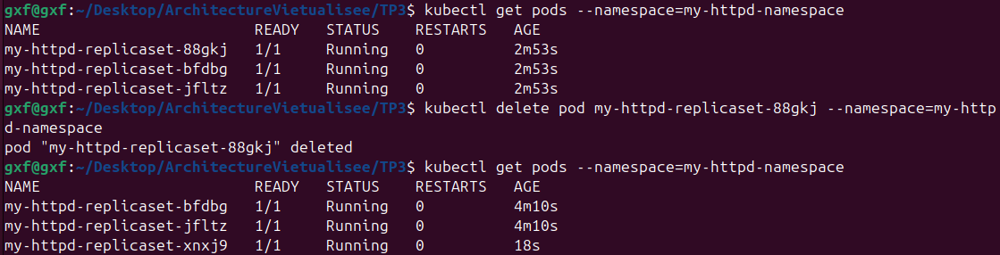

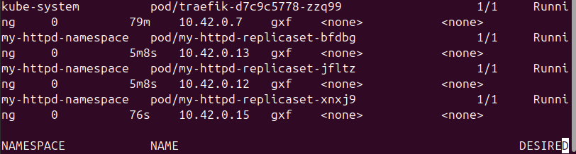

1. **What do you notice ?**

A new namespace my-httpd-namespace was created, and within it, the ReplicaSet my-httpd-replicaset successfully launched 3 Pods, all of which are running and ready as expected.

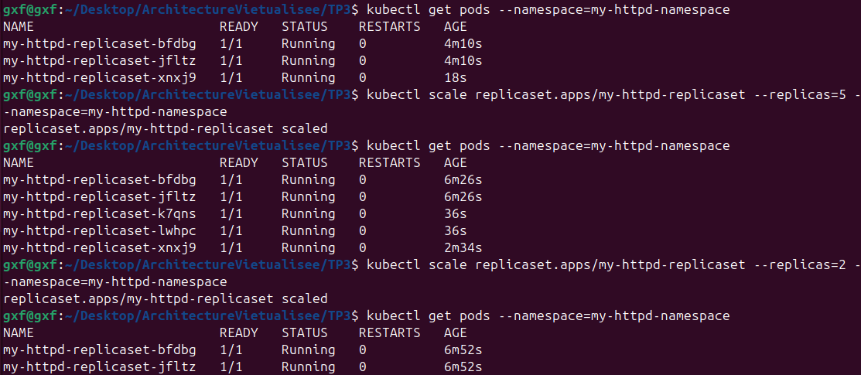

1. **What is the role of the ReplicaSet controller ?**

The role of the ReplicaSet controller is to ensure the desired number of pod replicas are running. When the ReplicaSet was scaled to 5, it created additional Pods to match the desired count. Similarly, when scaled down to 2, it terminated the excess Pods to maintain the updated desired state.

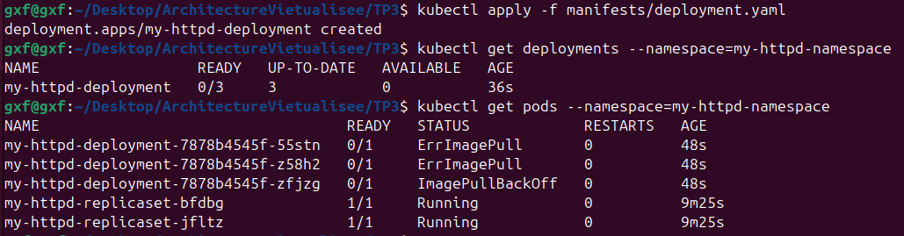

Image: httpd:2.4.46-alpine & Image: httpd:2.4.150-alpine

1. **What is the role of the Deployment controller ?**

The Deployment controller manages application updates by ensuring the desired state of Pods. Shown as the result, it updated the image from **httpd:2.4.46**-alpine to **httpd:2.4.150-alpine** using a rolling update. When an error occurred (e.g., ErrImagePull), it allowed rolling back to the previous stable version (httpd:2.4.46-alpine).

# Expose an Application

1. **What are the different possible ways to publish a service in Kubernetes ?**

In Kubernetes, services can be published usingClusterIP (internal access within the cluster), NodePort (external access via a specific port on each node), LoadBalancer (external access via a cloud provider's load balancer), or Ingress (HTTP/HTTPS routing for external access).

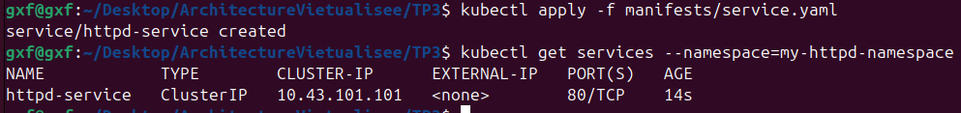

1. **How can a service "knows" which deployment to expose ?**

A service "knows" which deployment to expose by using labels and selectors. The service defines a selector that matches the labels assigned to the Pods created by the deployment. This allows the service to automatically route traffic to the appropriate Pods.

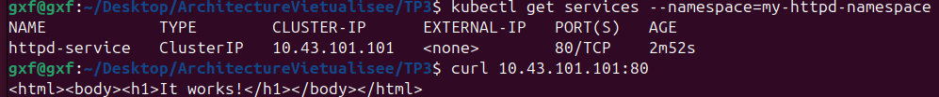

1. **What are your httpd service endpoints ?**

The httpd service endpoint is: **ClusterIP**: 10.43.101.101

This endpoint is accessible only within the Kubernetes cluster.

